CSC446: Final Report

Covid-19 Tracker

Team Members: Gary Choi / Kevin Salas

**Motivation**

The main motivation for this project derived from the current circumstances that the entire world is going through, which is the spread of Covid-19. When discussing the initial idea, we wanted to create something that would be relevant and useful. We also considered the tools and resources that we needed to make our idea into a final product. The skills that some of the team members possessed or lack thereof were also taken into consideration. The idea was to choose a topic and design that would both be challenging yet be able to accomplish to present a final product. We knew this idea was going to be both challenging and a learning experience for us. Additionally, the lessons learned throughout the semester were also going to take part in the process to better our experience.

**System Requirements**

* Windows:

Windows 10 (32-bit and 64-bit)

* MacOS:

11 (Big Sur)

10.15.x (Catalina)

10.14.x (Mojave)

10.13.x (High Sierra)

iOS 10 or later

* Android:

Android 7 or later

* Browser Versions:

Chrome 88, 89

Internet Explorer 11

Safari 13, 14

Firefox 85, 86

Microsoft Edge

**System Functions**

The system was designed to give the user a visual understanding of the current numbers concerning the spread of Covid-19 cases in the United States. This information includes the confirmed cases, number of deaths, and the fatality percentage rate. The user is presented with the map of the United States and can select a particular state to see the corresponding data to that state. The user is provided with a slider to filter for a specific date range. Additionally, there is a tab selection option at the top of the U.S. map to switch the views from the confirmed cases and total deaths. Each state is highlighted to the corresponding color dependent on the severity of the number of cases. It ranges from blue being the least severe, yellow being in the middle, and red as the most severe states. At the bottom of the page, the user is presented with a historical graph for a visual representation of the spread of Covid-19. In figure 1, you will find the Covid-19 interface with the location and description of each feature that we have covered in this section.

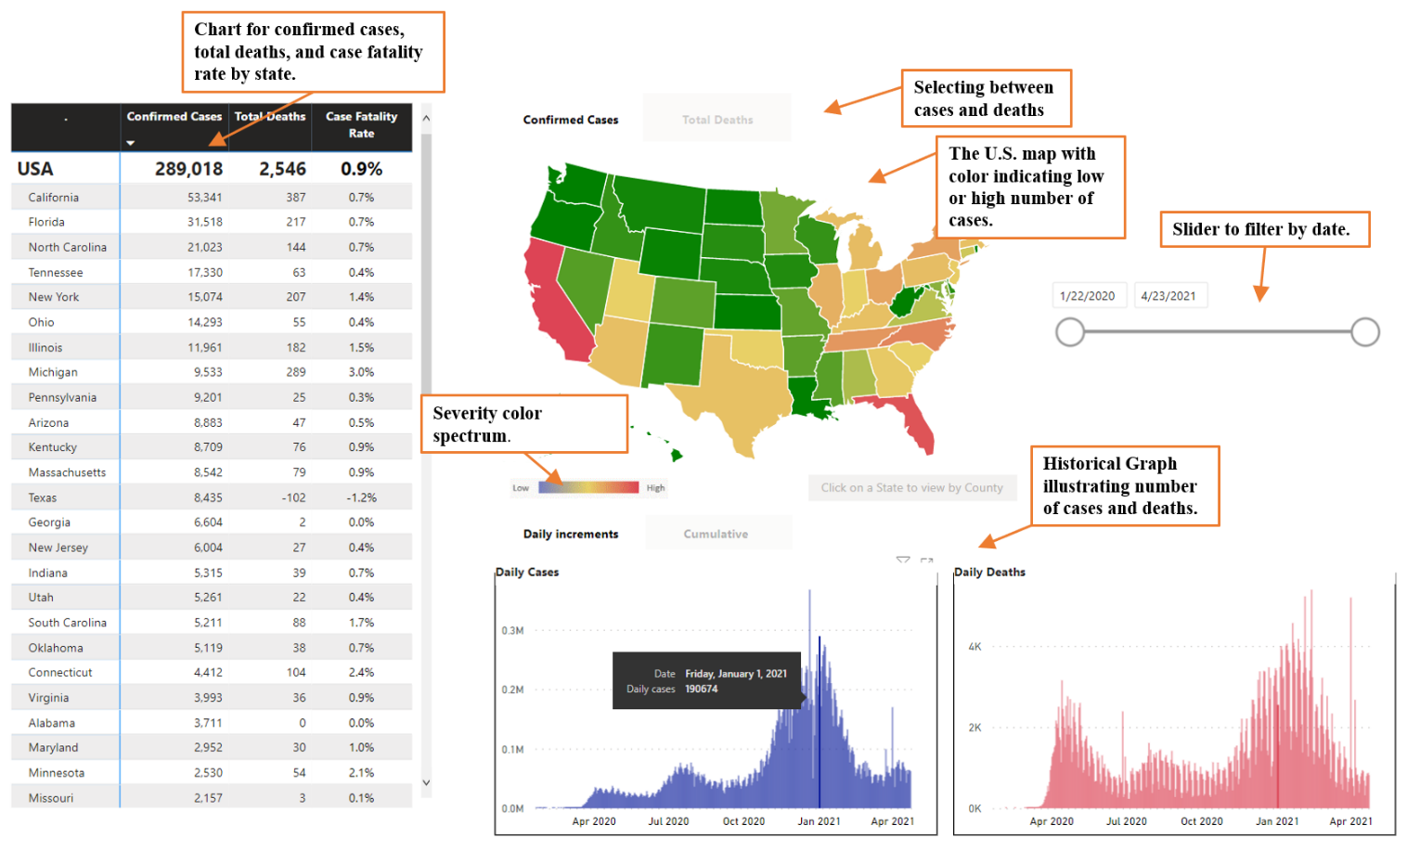

Figure : Covid-19 Tracker Interface

Other features that the user can interact with include the selection of each individual state. The user can select the state, and the interface will highlight the selected state. The date filter can also be adjusted to give the user control over what data they may want to see. After selecting a state and filter, the user is presented with only the data for the specified selection. The data chart will convert to only one row, and the historical graph will adjust to illustrate the corresponding data. Figure 2 illustrates the tracker with filtered parameters as discussed in this section. Another unique feature that I would like to point out when hovering over the historical graph with your mouse pointer will display the corresponding data in that section. This is illustrated in figure 3 and pointed out for better identification.

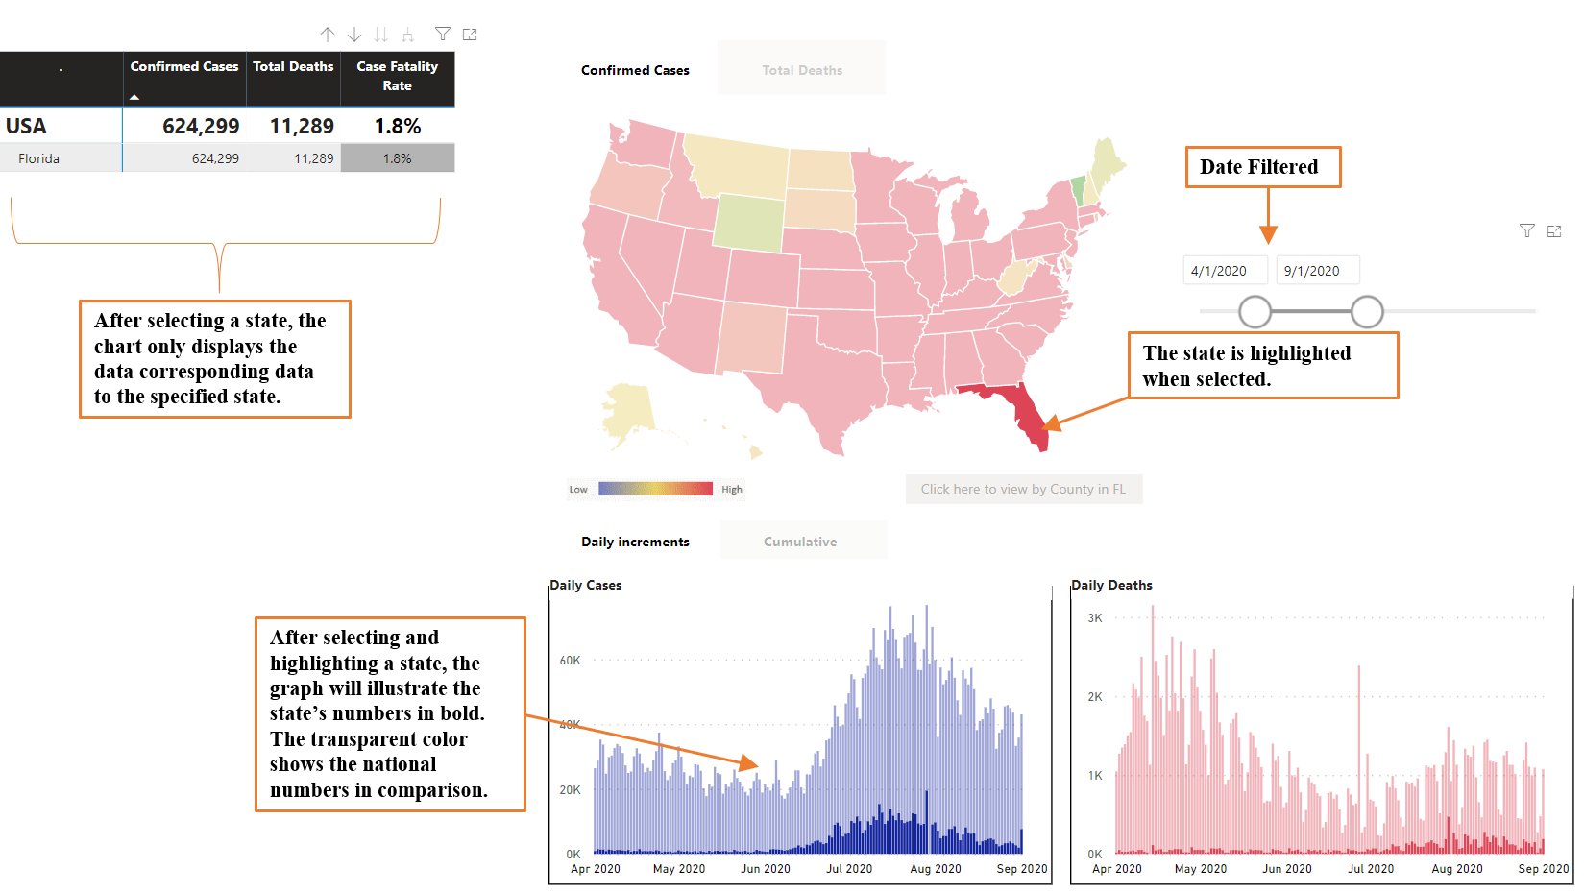

Figure : Covid-19 Tracker with Filtered Parameters

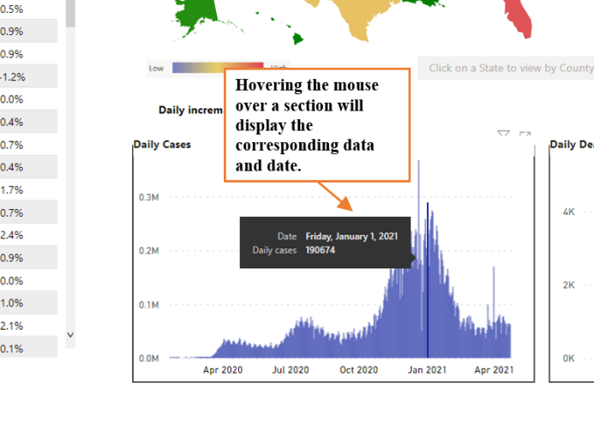

Figure : Hovering Over Historical Graph

**Architecture**

The architecture of the software revolves around the data that is being used. The interface displays the information to the user. The interface contains tools that allow the user to determine what type of data they may want to observe. These parameters include a selection of the case being confirmed cases or total deaths. It also requests data that the user may select the date and/or state which they may want to view. Figure 4 shows a Data transfer diagram that shows the exchange of data from the source to the interface.

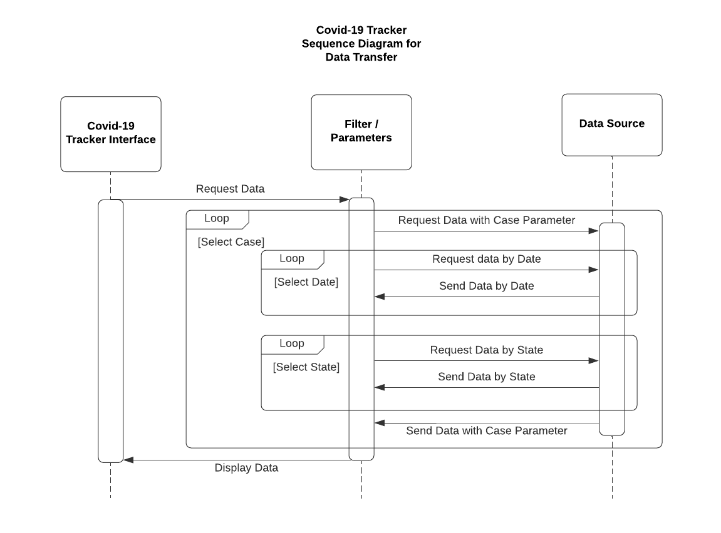

Figure : Covid-19 Data Transfer Diagram

Sources for the data:

Cases:

<https://static.usafacts.org/public/data/covid-19/covid_confirmed_usafacts.csv>

Deaths: <https://static.usafacts.org/public/data/covid19/covid_deaths_usafacts.csv?ga=2.54725931.1863768484.1619300601-44874492.1618375607>

**Implementation of the System**

**Phase 1: Data sanitization with RStudio**

//A.csv is empty flat file for formatting

covid = read_csv("Z:/Education/CSC/CSC446/Final/CSC/A.csv", col_types = cols(`County Name` = col_character(),

State = col_character(), stateFIPS = col_double(),

Date = col_date(format = "%m/%d/%Y"),

Cases = col_double(),

FIPS = col_double(),

Deaths = col_double()))

confirmed <- read_csv("[dir]/covid_confirmed_usafacts.csv", col_types = cols(StateFIPS = col_double()))

death <- read_csv("[dir]/covid_deaths_usafacts.csv", col_types = cols(StateFIPS = col_double()))

#i for State

for(i in 1:3193)

{

#j for date

for(j in 5:462)

{

# i= 1 j=462

a = i * 458

#458

b = j - 4

#458

c = 458 - b

#0

# a-c = 458

covid[a - c,1]=confirmed[i,2]

covid[a - c,2]=confirmed[i,3]

covid[a - c,3]=confirmed[i,4]

covid[a - c,4]=as.Date(names(confirmed)[j])

covid[a - c,5]=confirmed[i,j]

covid[a - c,6]=confirmed[i,1]

covid[a - c,7]=death[i,j]

}

}

write.csv(covid, "[dir]/covid_Final.csv",row.names = FALSE)

**Phase II: Generating Form with PowerBI**

1. Import Data (covid_Final.csv)
2. Create State Dimension Table (WA – Washington relationship)
3. Create Relationship between covid_Final$state and stateDimension$stateCode
4. Create interfaces (Maps, Graphs, Chart, Date Filter) and assign appropriate columns
5. Create buttons and bookmark, and assign appropriate functions
6. Create Embedded HTML code

**Phase III: Deployment with Xampp**

1. Download Xampp and Enable Mysql and Apache services
2. Create index.html file and include the Embedded HTML code from Phase II
3. Launch the web browser and connect to <http://localhost/index.html>

The Covid-9 Tracker can be used by healthcare professionals in getting a visual understanding of where the virus may be spreading the most. It is also intended to be used by the public in getting useful information to implement safety measures for preventing infection.

**Testing, Evaluating, and Updating of the System**

The original intention for creating the software was to use PHP, but it presented challenges in the form of limitations. WordPress was another option considered, but there was a JSON importer permission issue. Other challenges that were encountered were data not being updated. The original source for the data stopped updating the information around the month of March and decided to use other sources.

Initial testing was conducted for the interface, ensuring that the proper information was being displayed accurately. Making sure that the color spectrum was being implemented in the system properly was also observed. When selecting the states individually, the information displayed had to be properly displayed in all the visual diagrams. Initial implementations started with a prototype shown in figure 5. I have also included an image displaying the issue encountered with the JSON content importer as Figure 6.

For any future modifications, we would consider incorporating real-time data. This would provide the user with daily updated information. Another modification would be to add data pertaining to persons being fully vaccinated. This would be a useful addition to the graph, which provides the user with more information on the spread of Covid-19. Additionally, the software could be modified in such a way to provide more accurate information concerning the state’s counties.

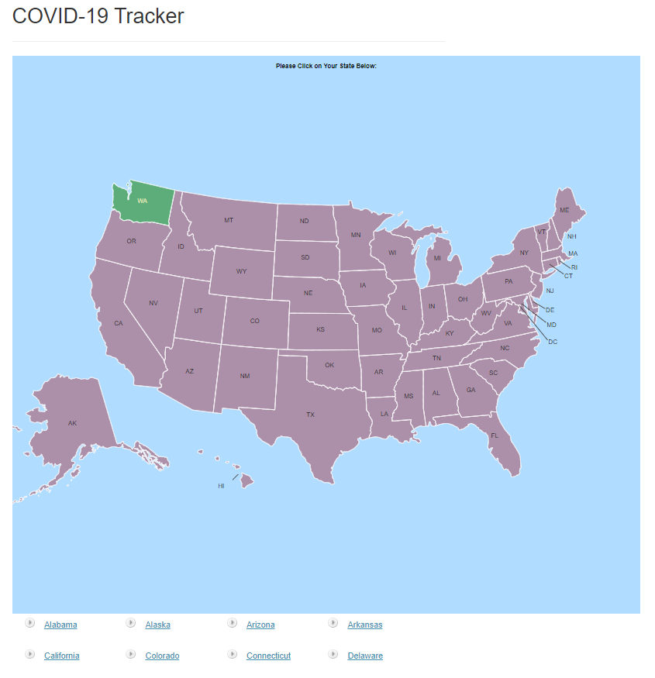

Figure : Covid 19 Tracker Prototype

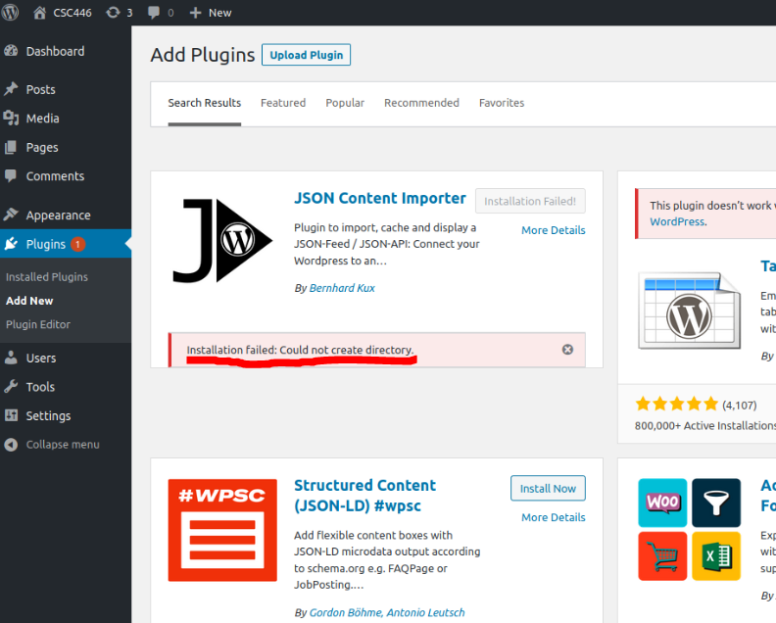

Figure : JSON Importer Permission Issue